**Chapter 5 – Programming Assignment Hung Le**

**Question 1:**

|  |  |  |
| --- | --- | --- |
| **Defining table** | | |
| **Input** | **Processing** | **Output** |
| * Radius * Height | * Multiply radius by radius * Multiply the result by height * Multiply the result by PI | * Volume of the cylinder |

let prompt = require('prompt-sync')();

let r = prompt("Please enter radius: ");

let h = prompt("Please enter height: ");

r = parseFloat(r);

h = parseFloat(h);

let v = Math.PI * r * r * h;

console.log(v);

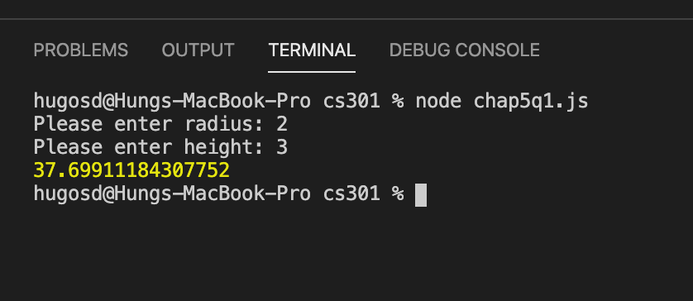

**Question 2:**

|  |  |  |
| --- | --- | --- |
| **Defining table** | | |
| **Input** | **Processing** | **Output** |
| * Volume in quarts | * Divide volume in quarts by 1.0567 | * Volume in liters |

let prompt = require('prompt-sync')();

let vQ = prompt('Please enter volume in quarts: ');

vQ = parseFloat(vQ);

let vL = vQ/1.0567;

console.log(vL);

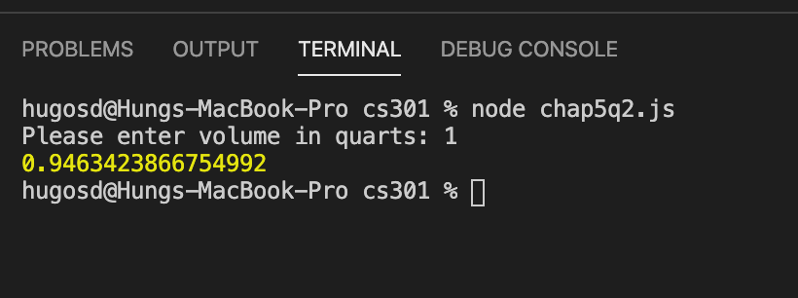

**Question 3:**

|  |  |  |
| --- | --- | --- |
| **Defining table** | | |
| **Input** | **Processing** | **Output** |
| * Distance in meters | * Divide the length in meters by 1609 | * Distance in miles |

let prompt = require('prompt-sync')();

let distanceMeters = prompt('Please enter distance in meters: ');

distanceMeters = parseFloat(distanceMeters);

let distanceMiles = distanceMeters/1609;

console.log(distanceMiles);

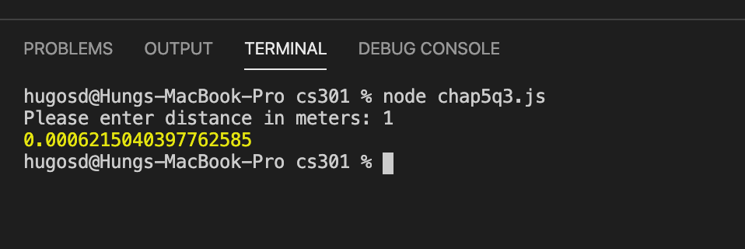

**Question 4:**

|  |  |  |
| --- | --- | --- |
| **Defining table** | | |
| **Input** | **Processing** | **Output** |
| * Number of boxes * Number of stacks | * Divide the number of boxes by the number of stacks. * Round up the result to the next largest integer. | * Number of stacks. |

let prompt = require('prompt-sync')();

let numberOfBoxes = prompt('Please enter the number of boxes: ');

let numberOfBoxesInEachStack = prompt('Please enter the number of boxes in each stack: ');

let numberOfStack = Math.ceil(numberOfBoxes/numberOfBoxesInEachStack);

console.log(numberOfStack);

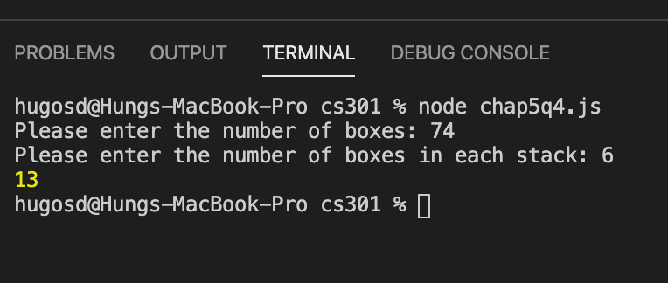

**Question 5:**

|  |  |  |
| --- | --- | --- |
| **Defining table** | | |
| **Input** | **Processing** | **Output** |
| * Number of students * Number of teams | * Divide the number of students by the number of teams. Round up the result to the next smallest integer to get the number of students in regular team. * Divide the number of students by the number of teams. Use the modulus operator to get the remainder. The remainder is the number of large teams that have one more student than the regular team. * Subtract the number of large team from the number of team to get the number of regular team. * Add 1 to the number of students in regular team to get the number of students in large team. | * Number of regular team. * Number of students in regular team. * Number of large team. * Number of students in large teams. |

let prompt = require('prompt-sync')();

let numberOfStudents = prompt('Please enter the number of students: ');

let numberOfTeams = prompt('Please enter the number of teams: ');

let studentRegularTeam = Math.floor(numberOfStudents/numberOfTeams);

let numberLargeTeam = numberOfStudents % numberOfTeams;

let numberRegularTeam = numberOfTeams - numberLargeTeam;

let studentLargeTeam = studentRegularTeam + 1;

console.log(`${numberLargeTeam} teams with ${studentLargeTeam} members and ${numberRegularTeam} teams with ${studentRegularTeam} members`)

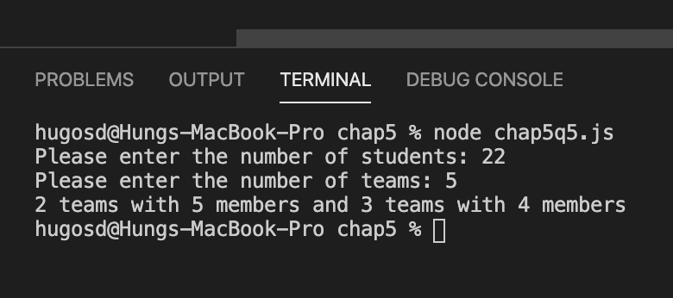

**Question 6:**

|  |  |  |
| --- | --- | --- |
| **Defining table** | | |
| **Input** | **Processing** | **Output** |
| * Beginning of odometer reading * Ending of odometer reading in miles * Number of gallons of gasoline used in miles | * Subtract the beginning odometer reading from the ending odometer reading * Divide the result by the gallons of gasoline used | * The mileage in miles per gallon |

let prompt = require('prompt-sync')();

let beginningOdo = prompt('Please enter the beginning odometer reading in miles: ');

let endingOdo = prompt('Please enter the ending of odometer reading in miles: ');

let gasUsed = prompt('Please enter the amount of gasoline used: ');

beginningOdo = parseFloat(beginningOdo);

endingOdo = parseFloat(endingOdo);

gasUsed = parseFloat(gasUsed);

let gasPerMileage = (endingOdo-beginningOdo)/gasUsed;

console.log(gasPerMileage);

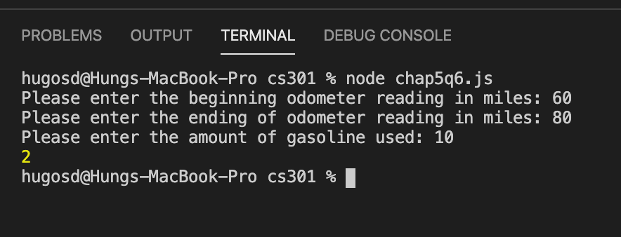

**Question 7:**

|  |  |  |
| --- | --- | --- |
| **Defining table** | | |
| **Input** | **Processing** | **Output** |
| * Age | * Subtract age from 220 to get heart’s maximum rate per minute * Multiply maximum rate by 0.65 to get the slowest rate * Multiply maximum rate by 0.85 to get the highest rate | * The slowest heart rate per minute * The highest heart rate per minute |

let prompt = require('prompt-sync')();

let age = prompt('Please enter your age: ');

let maximumHeartRate = 220 - age;

let slowestHeartRate = maximumHeartRate * 0.65;

let highestHeartRate = maximumHeartRate * 0.85;

console.log(`Your slowest heart rate per minute should be ${slowestHeartRate}, your highest heart rate per minute should be ${highestHeartRate}.`)

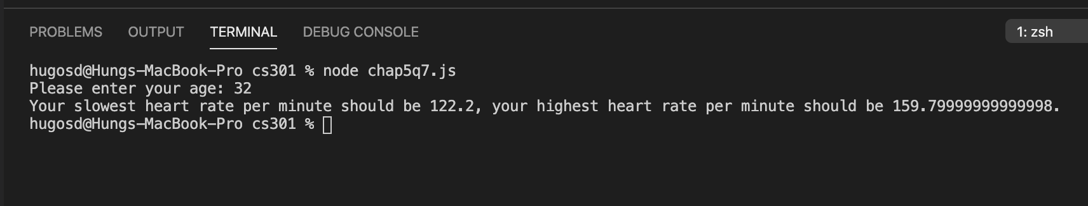

**Question 8:**

|  |  |  |
| --- | --- | --- |
| **Defining table** | | |
| **Input** | **Processing** | **Output** |
| * Employee’s regular working hours. * Employee’s wage. | * Multiply employee’s regular working hour. * Compute employee’s gross pay. Multiply employee’s regular working hour by employee’s wage. * Compute employee’s tax. Multiply employee’s gross pay by 0.15. * Compute employee’s after-tax pay. Subtract tax from employee’s gross pay. | * Employee’s after-tax pay. |

let prompt = require('prompt-sync')();

let regHours = prompt("Please enter the emplpyee's regular working hours: ");

let regWage = prompt("Please enter the employee's wage: ");

regHours = parseFloat(regHours);

regWage = parseFloat(regWage);

let grossPay = regWage * regHours;

let tax = grossPay * 0.15;

let afterTaxPay = grossPay - tax;

console.log (afterTaxPay);

